**QSMART – TANK REPLACEMENT**

**PROCEDURE**

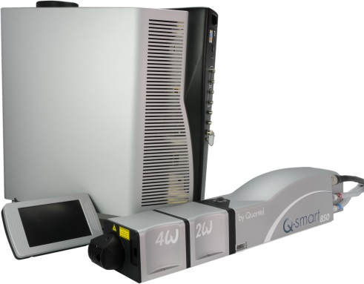

**Toolkit:**

Allen keys

**System**: QSMART

|  |  |
| --- | --- |
| **SM010356** | **Q-SMART CG TANK ASSEMBLY** |

**Purpose:** This document details how to change the tank

|  |  |  |
| --- | --- | --- |
| Revision | date | modification |
| Initial issue | July 4, 2014 |  |
|  |  |  |
|  |  |  |
|  |  |  |

# 

# DISASSEMBLY

* Open the ICE and the cooling group

*See procedure "CG - SM010355- COOLING GROUP ASSEMBLY"*

* Remove the temperature sensor and the level sensor by unscrewing.
* Remove the hoses from the pump and flowmeter.
* Remove the metal Tyrap from the tank
* Remove the tank

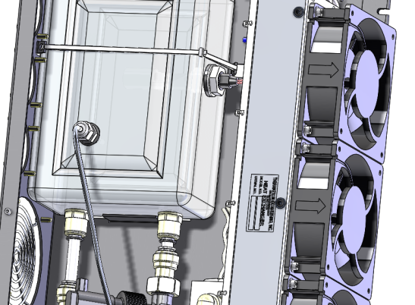

Remove the temperature sensor and the level sensor by unscrewing.

Remove the hoses from the pump and flowmeter.

Remove the metal Tyrap from the tank

# INTEGRATION OF THE TANK

|  |  |  |
| --- | --- | --- |
| 1.00 | 4/CBL/0539 | TYRAP LONG 520 METALLIQUE |

* Put the tank on the support and insert the pump and flowmeter tubes.
* Fasten the tank with a metal Tyrap



2-Fasten the tank with a metal Tyrap

1-Insert the pump and flowmeter tubes.

* Reinstall the level sensor

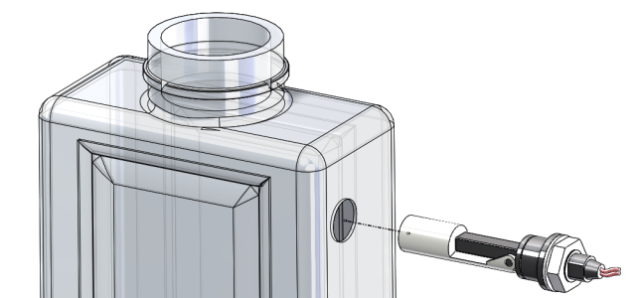

Insert the level sensor (4/CAP/0056) into the side hole of the tank like shown (with the float down).

Tighten the nut when the seal is in contact with the reservoir.

* Insert the temperature sensor



Screw the sensor into the tank

# TEST AND CLOSING

* Perform the CG test and close.
* Close the ICE

*Refer to "Test and CG-closure" and "CG - SM010355- COOLING GROUP ASSEMBLY"*